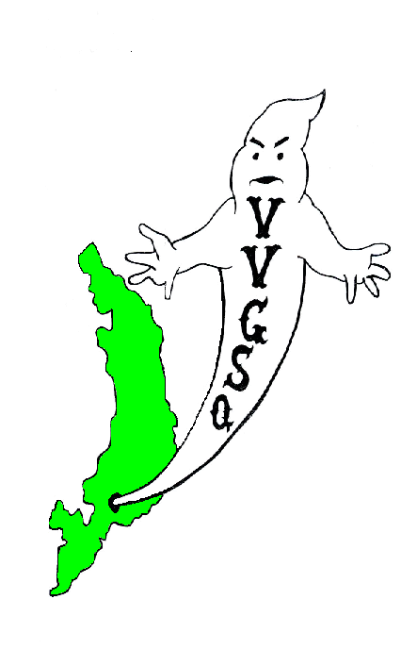
Vietnam Veterans Group of San Quentin

September 2012 General Meeting
Held in the Library on September 30, 2012.

EXECUTIVE COMMITTEE:

Chairman | Chris Schuhmacher
Vice-Chairman | James Snider
Secretary/Treasurer | Dave Basile
Outside Coordinator | Greg Sanders
North Block Member-at-Large | Ernie Vick
H-Unit Member at Large | John Warren
West Block Member at Large | Craig Johnson

Sgt. of Arms Robinson called the group to attention to pay honor to our Flag. All present were asked to remove their hats for a moment of silence for those Missing-in-Action, those Killed-in-Action, and all other service members deployed in Iraq, Afghanistan, and around the world.

Chairman Schuhmacher called the meeting to order at 0915 hrs. Roll was called: 41 members present, 1 absent and 2-excused absences - there was a quorum. Our sponsor, Lt. K. Evans, was present. JLynn Manley and Gloria Godchaux also attended. Thank you for joining us.

All members were asked if they received the August 2012 General Meeting minutes. All members did receive their minutes except for Mr. Soltero, J. Manley and G. Godchaux. A motion to accept the minutes requested by Mr. Johnson, seconded by Mr. Rooke, and the motion passed.

SECRETARY/TREASURER'S REPORT:
We have in our account $2,292.24. $500.00 was donated to Operation Moms per membership vote in August 2012 meeting.

OUTSIDE COORDINATOR’S REPORT:
Mr. Sanders: No correspondence has been received since our last meeting. Mr. Sanders introduced “Holiday Mail for Heroes”, that would require cards completed by veterans and mailed out. Mr. Sanders stated he would contact the Chapels to see if cards could be donated for this purpose.

COMMITTEE CHAIRMAN’S:

BY-LAWS:
Chairman Stan Baer: Currently working on By-Law revision to change wording etc.

SCHOLARSHIP:
Chairman J. Robinson: Nothing to report at this time.

HONOR GUARD:
Chairman Trent Capell: Mr. Johnson requested that all Honor Guard members meet on this Thursday at 0900 hrs to practice for the Veterans’ Day event. Meet at the Recreation shack 10/4/12 2 0900 hrs.

HISTORIAN/WEBSITE:
Chairman G. Sanders: Asked Committee members to stay after the meeting to discuss changes.

STAMPS FOR SOLDIERS:
Chairman P. Rooke: Expressed concern about mailing out stamps and tabs. Also concern about storage of tabs. Stand by, as I believe I have a solution and will reveal this at our next meeting.

FUND RAISER:
Chairman J. Hernandez: Still in the proposal stage of introducing a mini canteen run by veterans for the inmate population. Items would be canteen items sold when the canteen is closed. Yard ducats or a means to account for funds need to be developed.

PRESENTATION AWARDS:
Chairman J. Gomez: Making plaques in PIA. Mr. Gomez asked for amount and Chairman Schuhmacher stated 15. In addition, Mr. Gomez said he would bring a prototype in for all to see.

CAMARADERIE NIGHT:
Co-Chairman’s J. Warren stated nothing to report, as there is no sponsor available for this month. Mr. H. Barton stated the softball field is available Sunday mornings from 0900 to 1230 hrs. It was decided that all interested players report to the softball field on 10/21/12 for a game.

SQ MEDIA
Chairman Schuhmacher thanked Mr. Stauffer for his contribution last month and informed the group that Angel Falcone wants to write an article about the Veterans group. Mr. Barton (Longest tenured member) and Mr. Beavers (oldest member) will be available for an interview. Mr. Farris was appointed head of the musical theme (Background music) department.

TOY PROGRAM
Co-Chairman’s G. Caffale and B. Spillman: Flyers for visiting room going up in October and requests to ILTAGS and Chaplains for donations are going out this week. Lt. Evans is ordering toys this month.

FLAG FOLDING
Chairman D. Tarvan: Request two US flags 5’ x 9’, aside from that, nothing new to report.

VIP OFFICE:
The next scheduled workshop is October 19, 2012.

OLD BUSINESS:

Mr. Rooke brought in the Veterans Remembrance Flag he introduced in July. Mr. Rooke took several minutes to explain what this flag represents: “The flag depicts the founding of our nation by the 13 stars that emanate from the hoist to the large red star that represents our nation and the five branches of our country’s military that defend her. The white star indicates the Veteran’s dedication to service. The blue star honors all who serve in the military in the past, present and future. The gold star memorializes those who fell defending our Nation. The green field represents the hallowed ground where all rest eternally.” In addition, our gratitude to Mr. Jim Parks, creator of the flag that commemorates those who have given back to the United States. Special thanks to the Sonoma Veterans Memorial Park Association for donating this flag to the V.V.G.S.Q. It will be hoisted at all our meetings and special events as well as this Veterans’ Day Roll Call, Honoring those who have fallen. Thanks Mr. Rooke for bringing this flag into the group. It is an asset that is very significant to our groups’ purpose.

NEW BUSINESS:
Mr. Schuhmacher asked Mr. Snider to address the membership regarding the Kid Cat hygiene drive for children. Mr. Snider reported to the group how and why the VVGSQ became involved. To date, representatives of the VVGSQ have attended two meetings to discern what involvement if any the VVGSQ will utilize in support of Kid Cat. The two suggestions emanating from this discussion was Gloria stated to the group that in supporting Kid Cat would not conflict with our obligations to Operation Mom and Veterans’ Tarvan and Stewart were selected to represent the VVGSQ in further meetings in order to get more information. Mr. J.D. Martin made a motion to salute the flag at the close of our meetings. It was seconded by Mr. Robinson and passed the floor vote. Discussion on the Tabs project is tabled for the October meeting. Lt. Evans stated that the Administration is pushing for a name change to be more in line with the current veterans’ returning from deployment. No discussion took place, but all were asked to think about this. Lt. Evans also informed the group about the new test program that schedules visitation by appointment. Additional information can be located at http://www.cdcr.ca.gov. (Click on visitation tab). Veteran Pedro Espinal was asked to leave the room while the general membership convened to vote him in as a member. The vote passed in favor of acceptance. Congratulations Pedro and welcome aboard. That concluded New Business.

Chairman Schuhmacher thanked Lt. Evans, Gloria Godchaux, and JLynn Manley for attending on behalf of the entire group.

A motion to adjourn the meeting by Mr. Stauffer and seconded by Mr. Hernandez A vote was taken and the motion passed. The meeting adjourned at 1030 hrs.

UPCOMING EVENTS

October 21, 2012 | Camaraderie Baseball Game on the Yard @ 0900 hrs
October 28, 2012 | General Meeting in the Library @ 0900 hrs
November 11, 2012 | Veterans Roll Call on lower yard @ 0900 hrs
November 25, 2012 | General Meeting in the Library @ 0900 hrs
Dec 15, 16, 2012 | Holiday Toy Program in Visiting Room
Dec 22, 23, 2012 | Holiday Toy Program in Visiting Room

Submitted,

__________________________ __________________
D. Basile, DATE
V.V.G.S.Q. Secretary / Treasurer

__________________________ __________________
C. Schuhmacher DATE
V.V.G.S.Q. Chairman

NOTED

__________________________ __________________
R. Luna DATE
Correctional Lieutenant
V.V.G.S.Q. Co-Sponsor

Vietnam Veterans Group of San Quentin  Attn: Lt. K. Evans, Chief sponsor  San Quentin State Prison  1 Main Street  San Quentin, CA 94964-0001  Website: http://vvgsq.tripod.com/ | Chief Sponsor: Lt. K. Evans, (415) 454-1460 x 5205  Co-Sponsor: Lt. R. Luna, (415) 454-1460 x 5808

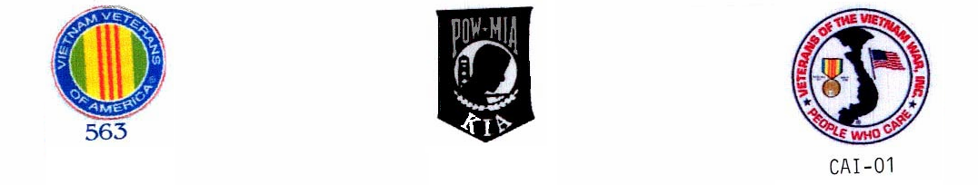
CURRENT ROSTER as of 9/30/12

 | NAME | CDC # | HOUSE | ETH. | CUST. | STATUS | COMMENTS
√ | ADAMS DWIGHT | K-98701 | 1N073L | BLK | CLOB | Voting Mbr | Fundraiser
√ | ARNOLD, RICHARD | P-27171 | 2N069U | WHI | CLOB | Voting Mbr | Website/Historian
√ | BAER, STAN | K-06285 | 3N039U | WHI | MEDA | Voting Mbr | VIG, Toy Prog/By-laws Chr
√ | BARTON, HARRY | C-03120 | 2W068L | WHI | MEDA | Voting Mbr | VIG, Camaraderie
√ | BASILE, DAVID | C-70016 | 1N038U | WHI | MEDA | Voting Mbr | Secretary/Treasurer
√ | BEAVERS, LAWSON | P-14974 | 1N015L | BLA | CLOB | Voting Mbr | VIG, Honor Guard, Toy Prog, Camd.
√ | BELL, CHRISTOPHER | K-01545 | 3W001L | BLA | CLOB | Probationary | Probationary until Nov 25, 2012
√ | BOTHA, GARY | D-88086 | 1W095L | WHI | MEDA | Voting Mbr | Scholarship
√ | BUTLER, DUANE S. | D-91464 | 2N017L | BLA | MEDA | Voting Mbr | VIG, Fundraiser
√ | CAFFALE, GEO | D-97941 | 3N098L | WHI | MEDA | Voting Mbr | VIG, Toy program co-Chr.
E | CAPELL, TRENTON | E-91949 | 3N011U | BLA | CLOB | Voting Mbr | Chairman Honor Guard
√ | COLEMAN, RONALD | C-87435 | 2W010L | BLA | MEDA | Voting Mbr
√ | COOPER, GARY | T-15604 | 3W013L | WHI | CLOB | Voting Mbr | Toy Program
√ | DANIELS, ISIAL | K-37959 | 2W022l | BLA | MEDA | PROBATION | Probationary/By-Laws,Scholar
√ | ESPINAL, PEDRO | K-94652 | 1N087U | OTH | CLOB | Voting Mbr
√ | FAISON, POPEYE | C-68462 | 2N028U | BLA | MEDA | Voting Mbr | VIG,Toy Program
√ | FARRIS, DARRYL | T-33812 | 5N071U | BLK | CLOB | Voting Mbr | Scholarship
√ | GASKINS, SAMUEL | C-27569 | 3W079L | BLK | MEDA | Voting Mbr | Honor Guard, Flag Folding
√ | GOMEZ, JOHNNY | K-72622 | 4N042L | MEX | CLOB | Voting Mbr | VIG, Awards Ch. Toy Prog.
√ | GOODLOW, KENNETH | C-75705 | 1D043L | BLA | CLOB | Voting Mbr | Camaraderie
√ | GUMPAL, MAURO | P-00591 | 4N036L | OTH | CLOB | Voting Mbr | Honor Guard
√ | HARRIS, MARVIN | C91589 | 2W093L | BLK | MEDA | Voting Mbr | Toy Program
√ | HERNANDEZ, JESSE | K-21116 | 2W036L | WHI | MEDA | Voting Mbr | Fund raiser Chairman Website
√ | HYLTON, ROBERT | AI4554 | 4H077L | WHI | MEDA | Voting Mbr | Toy Program, Camaraderie
√ | JOHNSON, CRAIG | C-08327 | 4W063L | WHI | MEDA | Voting Mbr | VIG,Honor Guard, WB Mbr @ Large
√ | JOHNSTON, JOHN | F01795 | 4H045L | WHI | MEDA | Voting Mbr | Camaraderie
√ | JONES, MALCOLM | J-04780 | 5W010L | BLA | CLOB | Voting Mbr | VIG
√ | KASER, BOB | D-41415 | 2N025L | WHI | MEDA | Voting Mbr | VIG
A | KESS, PHILLIP | G-62396 | 5H057L | BLA | MEDB | Voting Mbr
√ | MARTIN, J.D. | D-44170 | 4W075L | BLA | MEDA | Voting Mbr | Flag Folding, Camaraderie
√ | POLLEY, AHMAD | C-57727 | 2W084L | BLA | MEDA | Voting Mbr | VIG, Honor Guard
√ | ROBINSON, GARVIN | K-52086 | 3N012L | BLA | CLOB | Voting Mbr | Honor Guard, Sch Chr.Flg Fldg
√ | ROOKE, PETE | C-76159 | 1N020L | WHI | CLOB | Voting Mbr | Tabs/Stamps for Soldiers
√ | SANDERS, GREG | E-05222 | 4W017L | WHI | MEDA | Voting Mbr | VIG Out Coor. Chr Website His
√ | SCHUHMACHER, CHRIS | T-31014 | 4N093L | WHI | MEDA | Voting Mbr | Chairman
√ | SNIDER, JAMES | F-30077 | 2N100U | WHI | CLOB | Voting Mbr | VIG, Vice- Chr. Media
√ | SOLTERO, DANIEL | D-65858 | 1W006U | WHI | CLOB | Voting Mbr | Honor Guard, DB Mbr @ Large
√ | SPILLMAN, GLEN | F-42695 | 3N035U | WHI | CLOB | Voting Mbr | VIG, Co-Chr. Toy Prog. Awards
√ | STAUFFER, PAUL | T-80750 | 3N065U | WHI | CLOB | Voting Mbr | Scholarship, Media
√ | STEWART, NORFLEET | E-90026 | 4W079L | BLA | CLOB | Voting Mbr | Honor Guard, Flag Folding
√ | STONER, JEFFREY | D03596 | 5W085U | WHI | MEDA | Voting Mbr | Website/Historian
√ | TARVAN, DAVID | E-76518 | 2W038L | WHI | MEDA | Voting Mbr | Honor Guard
√ | VICK, ERNIE | P-59262 | 2N016L | WHI | CLOB | Voting Mbr | VIG Scholar,Fund NB Mbr @ Lg
√ | WARREN, JOHN | T-86358 | 4H065L | MEX | MEDB | Voting Mbr | Cam Co-Chr H Mbr @ Large
√ | WOODS. JIMMIE | V-68113 | 5H035L | BLA | MEDB | Voting Mbr | Camaraderie
44

√ = Present
E = Excused Absence
A = Unexcused Absence

